# 

**INT404**

**PREDICTING QUALITY OF FRUIT FROM IMAGE**

END TERM REPORT

by

|  |  |  |
| --- | --- | --- |
| **Name of the student** | **Reg.No** | **Roll.No** |
| *N.Rajasekhar* | *11804068* | *50* |
| *E. Saikrishna* | *11805207* | *51* |
| *Y.Harsha vardhan reddy* | *11801861* | *52* |
| *B.Vara prasad* | *11802419* | *06* |

**SECTION:** K18HV



**Department of Intelligent Systems**

**School of Computer Science Engineering**

**Lovely Professional University, Jalandhar**

**April-2020**

**STUDENT DECLARATION**

This is to declare that this report has been written by us. No part of the report is copied from other sources. All information included from other sources have been duly acknowledged. We aver that if any part of the report is found to be copied, we shall take full responsibility for it.

**Name of student 1:**

N.Rajasekhar

Reg.No: 11804068

Roll.No:50

Github.link: <https://github.com/RajSekhar05/Ai_project>

**Name of student 2:**

E.Saikrishna

Reg.No:11805207

Roll.No:51

Github.link: <https://github.com/saikrishna7675/AI-PROJECT/tree/master>

**Name of student 3:**

Y.Harsha vardhan reddy

Reg.No:11801861

Roll.No:52

Github.link: <https://github.com/Harshareddy630/ai-project/tree/master>.

**Name of student 4:**

B.Vara prasad

Reg.No:11802419

Roll.No:06

Github.link: <https://github.com/Prasad784/PrasadAl?files=1>

**TABLE OF CONTENTS**

**TITLE PAGENO.**

**1.Background and Objective …………………….... 5**

**1.1 Introduction………………………………. 5**

**1.2 Objective……………………………… 6**

**2.Description of the project……………………… 6**

# 2.1 Method For Fruit Quality Detection……. 6

**2.2 WorkFlow of the Project………………… 7**

**2.3 Quality Detection of Fruits…………… 8**

**3.Implementation of scheduled work of project…………**

# 3.1 Image capture…………………………….. 9

# 3.2 Boundary extraction…………………….. 10

# 3.3 Geometric features extraction…………. 10

# 3.4 Colour, shape, and size features extraction….. 10

# 3.5 Method description…………………………….. 11

**4.Work Division…………………………………………… 15**

**5.Technologies and Framework Used……………………. 15**

**6.Conclusion………………………………………………. 15**

**BONAFIDE CERTIFICATE**

It is here been certified that this project report on “**PREDICTING QUALITY OF FRUIT FROM IMAGE**” is the bonafide work of N.Rajasekhar, E.Saikrishna, Y.Harsha vardhan reddy and B.Vara prasad who carried out the project work under my supervision.

Mr.Dipen Saini

Assistant Professor

Dept: Computer Science & Engineering

LPU

Phagwara

PUNJAB

**Background and Objective**

**INTRODUTION** :

Agriculture and Horticulture is one of the largest economic sectors and it plays the major role in economic development of India. Still in India, the traditional inspection of fruits is performed by human experts. A lot of time is wasted in the fields for checking the quality of the crops. The most important physical property is fruit size while colour resembles visual property. Hence, classification of fruit is necessary in evaluating agricultural produce, meeting quality standards and increasing market value. In recent years, computer machine vision and image processing techniques have been found increasingly useful in the fruit industry, especially for applications in quality inspection and shape sorting.

The ability to identify the fruits based on the quality in food industry is very important nowadays where every person has become health conscious. There are different types of fruits available in the market. However, to identify best quality fruits is cumbersome task. Therefore, we come up with the system where fruit is detected under natural lighting conditions. The method used is texture detection method, color detection method and shape detection. For this methodology, we use image segmentation to detect particular fruit. Fruit Detection project is implemented in MATLAB image processing toolbox. The project is implemented for both Real time and Non-Real time. The proposed method has four stages: First is Pre-Processing and second is Feature Extraction and third is Segmentation and fourth Recognition. In case of NonReal time, the first stage is used to browse the image, second stage is extraction of the features from images using Grey Level Co-occurrence Matrix (GLCM), RGB and Color Histogram. System will convert the image from RGB to grayscale image for further processing. The color histogram represents the distribution of colors in an image. Since image is captured under different illumination condition. In the third stage, the three extracted image is obtained in the form of red, green and blue. In the fourth stage, the extracted features are used as input to Support Vector Machine.

# Objective

The system starts the process by capturing the fruit’s image. Then the image is transmitted to the matlab for feature extraction, classification and grading. both classification and grading realized by fuzzy logic approach. The system is divided into two stages: The first stage is a training stage that is to extract the characteristics from the pattern. The second stage is to recognize the pattern by using the characteristics derived from the first task.

Colour and shape characteristics of fruits are decisive for visual inspection. An efficient autonomous system for fruit sorting must be able to adequately identify both parameters. Shape of fruits can easily be obtained from a digital image using classical techniques for image processing. There are wide varieties of colour systems present for the grading of fruits based on colours. There are some techniques like Fuzzy logic, Neural Network; Based on Colour Histogram, Genetic algorithm etc. Artificial neural network (ANN) is used to detect shape, size and colour of fruit samples.

# Description of the project

# Method For Fruit Quality Detection:

This proposed automated system is designed to overcome the problems of manual techniques. The system consists of several steps like feature extraction, sorting and grading. It is designed to combine three processes as shown below in a flow chart. Features like colour of fruit, shape of fruit and size of fruit are extracted. Size features are extracted in height and width. Extracting the size of fruit is called grading.

**2.2 WorkFlow of the Project:**

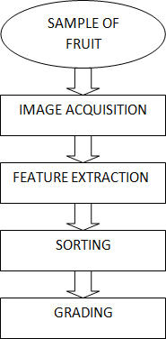

**2.3 Quality Detection of Fruits**

There are seven Steps for the fruit quality detection in proposed methodology. These steps are as following:

Step 1: Get image of fruit.

Step 2: This image is loaded into the matlab.

Step 3: Extract the features of fruit

Step 4: Train the neural network.

Step 5: Select the fruit sample for testing.

Step 6: Perform testing by using artificial neural network training module button.

Step 7: Artificial neural network based output

* The first step is to getting the image of fruit. Image of the fruit samples are captured by using regular digital camera with white background with the help of a stand.
* Then in the second step the image of the fruit is loaded into the matlab.
* In third step features of the fruit samples are extracted. Features such as colour, shape and size of the fruit sample are extracted.
* In fourth step neural network is used for training the data,
* After that in step fifth fruit sample is selected for testing from database.
* In step sixth testing is performed by using ANN training module button.
* Finally, in step seventh ANN based results are obtained.

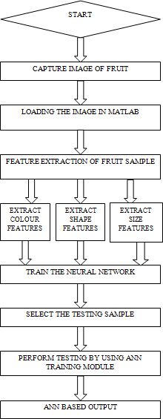

In this process, fruit samples are captured using regular digital camera with white background with the help of a stand. The image is loaded into matlab for processing. The features such as colour content and minor axis are extracted for sorting and parameters such as area and major axis length are extracted for grading the sample image. There are different modules which will perform different operations on the image being loaded. The modules are described as below:

# 3.1 Image capture:

An image of the fruit is captured by using any digital camera or any mobile phone camera, an image is captured. This image is loaded into the matlab by using the function “imread”. This function reads the image from the specified path. The image is stored in the matrix form of rows and columns. If it is a gray scale image, then it is stored as an M-by-N array. If the file contains a true colour image or RGB image, then it is stored as an M-by-N-by-3 array.

# 3.2 Boundary extraction:

As it is a coloured input it needs to be converted to grayscale by function “rgb2gray (image)” and the syntax is:I=rgb2gray(RGB).which converts the true colour image RGB to the gray scale intensity image I, and then the image is converted to binary before it is used for further processing in which image consists of only two colours namely black and white.

# 3.3 Geometric features extraction:

This starts with the extracted boundary of the sample. The function used to trace the features is “regionalcrops”. The main features extracted are Area, Major axis and Minor axis.

# 3.4 Colour, shape, and size features extraction:

In this red, green and yellow colours are used for classification as there is a difference between the fruit’s skin based on these colors. Hence these colours are helpful for sorting out the fruits. The red and green component is calculated by counting pixel values corresponding to the red and green colours and yellow component is calculated by first converting the RGB image to CMY by using the function. Separating one kind of sample from another, classification method is used. In this case, one kind of fruit is separated from the other set of fruits by using neural network. Extracting the size of the fruit is called grading. Size is an important criterion related to the market value of the fruit. Hence grading the fruit is important for the farmers before they sell their products.

# 3.5 Method description:

3.5.1 In this paper, fruit is graded based on the geometric features of the fruit namely area and major axis. In this approach the first step is that to initiate the GUI .

3.5.2 The next step is to train the network in which firstly the feature which we have taken for proposed methodology will be extracted. this section demonstrate the feature extraction part of proposed methodology it include the feature extraction of each and every sample in dataset for training of neural network.

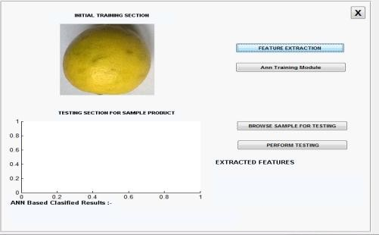

3.5.3 Final Step of this is testing part in which user has the option to select the sample of fruit which it want to test and finally want to asses it so in section include the selection of image file from testing

samples which will further perform testing and finally asses the selected sample into categories like First i.e. best, Second and third category.

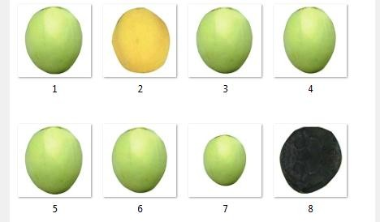

# Samples of fruit from Database

This part represent the graphical user interface after selecting the testing sample by the user next to it when user will click on ANN training module, then it shows neural network training tool. After that click on testing or perform testing this will give results and finally the parameters as values of features of testing.

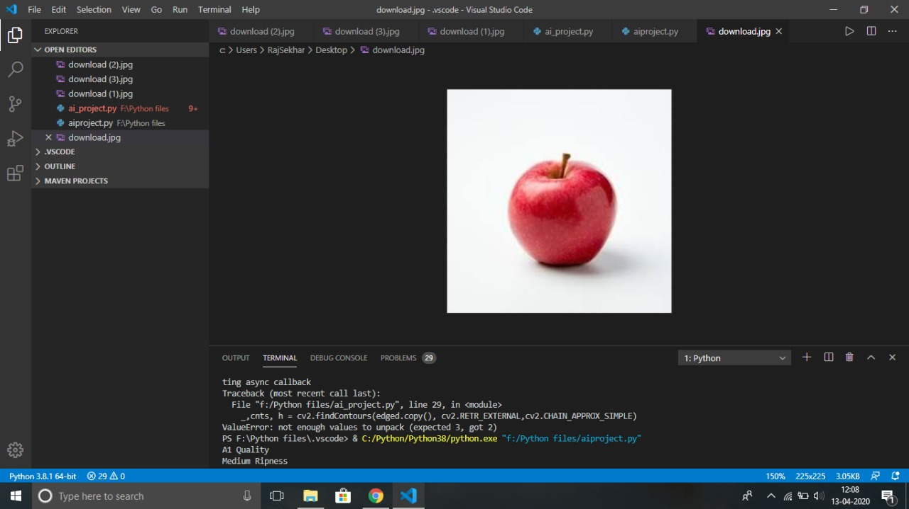.

# testing section for fruit sample

# 

# Final results of testing sample

# The results obtained after perform testing of selected sample into categories like first, second and third.

**Quality Detection Experimental Results And Discussion**

This section presents experiments and quality detection of fruit samples. In this paper three types of lemon fruits are used which are of different colour, shape and size. Results are based on different dimensions like size, shape, height and width where size A represents height and size B represents width.

based results for fruit sample 1

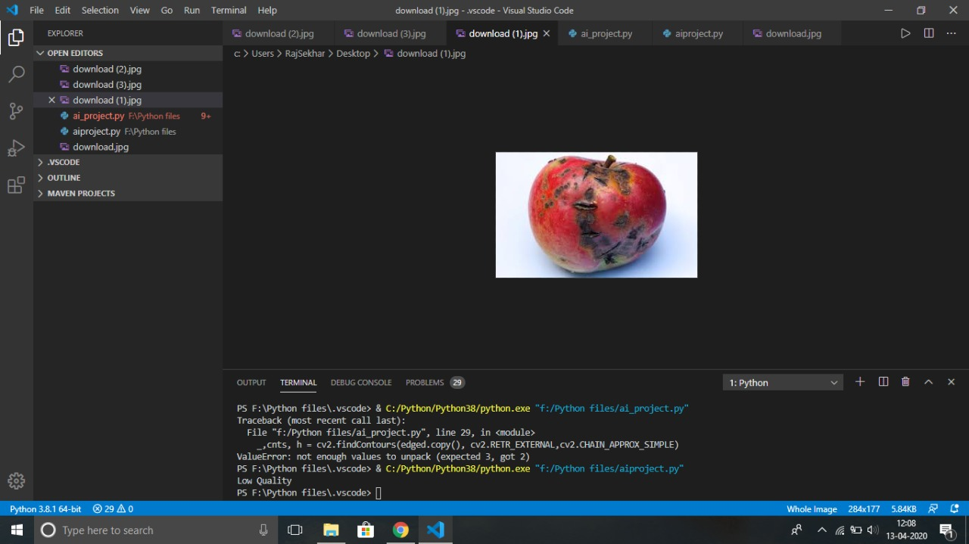

**based results for fruit sample 2**

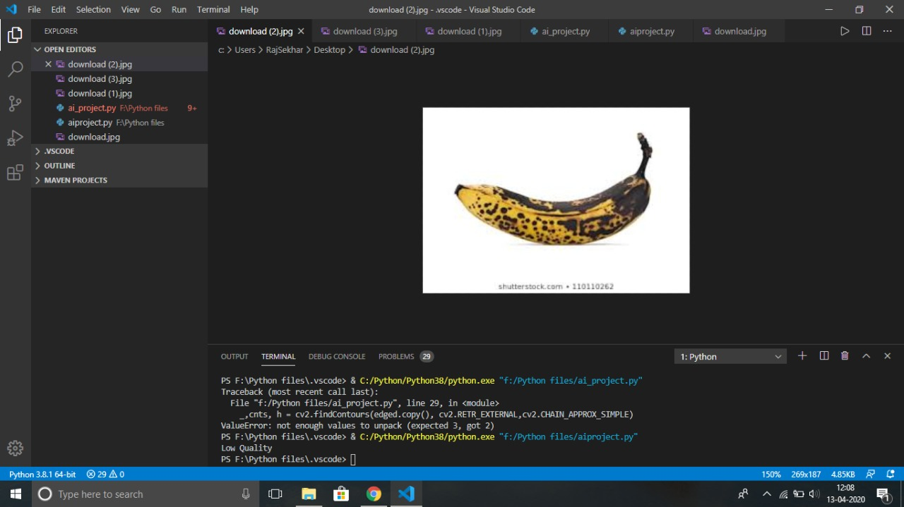

**4. Work Division:**

This project can’t be done by dividing the work of the project among us individually seprately.So,everyone revised the every concept and methodology used/related in making this project successful..

**5. Technologies and Framework used:**

When it comes to the technolgies and frameworks used in this project we choose to use python as the programming language to program the project hich quite easy to use, portable, extensible and much effiecient as of because it offers many libraries and frameworks like Tensorflow,matplotlib,pandas etc which plays a crucial role in this project.

**5. Conclusion**

The paper presents a new technique for quality detection of fruits. The technique is started by capturing the fruit’s image using regular digital camera or any mobile phone camera. The features are efficiently extracted from the sampled image. The extracted features are based on the parameters colour, shape and size.The quality is determined by using fruit features obtained . The proposed technique accurately detects the quality of fruits. The results are good for the three chosen lemon fruits of different colour, shape and size. This kind of system can be employed in juice plants, fruit and vegetable farms, packaging etc.